VIDHYADEEP INSTITUTE OF COMPUTER & INFORMATION TECHNOLOGY,ANITA-KIM.



**VEER NARAMD SOUTH GUJARAT UNIVERSITY**

**PROJECT REPORT**

**ON**

# “cloud computing”

**AS A PARTIAL REQUIREMENT FOR THE DEGREE**

**OF**

**BECHOLOR OF COMPUTER APPLICATION( BCA) Year 2023-2024**

**(TYBCA 6th Semester)**

Internal Guide:- SubmittedBy:-

**Mr.Partik Patel Hrahsla Jariwala**



**VIDHYADEEP INSTITUTE OF COMPUTER & INFORMATION TECHNOLOGY**

# CERTIFICATE

This is to certify that project report,submitted for the project entitled “**Cloud Computing”** has been carried out by **“Sunny Javiya”** at BCA department of vidhyadeep institute of computer & information technology, kim for partial fulfilment of BCA degree to be awarded by veer narmad south Gujarat university. this project work has been carried out under my supervision and is to my satisfaction.

Place :- kim

Date :-

**Internal Guide I/C Principal**

MR. Partik Patel Dr..Himansu Patel

# Cloud Computing

Cloud computing is the on-demand availability of computer system resources, especially data storage (cloud storage) and computing power, without direct active management by the user. Large clouds often have functions distributed over multiple locations, each of which is a data center. Cloud computing relies on sharing of resources to achieve coherence and typically uses a pay-as-you-go model, which can help in reducing capital expenses but may also lead to unexpected operating expenses for users.

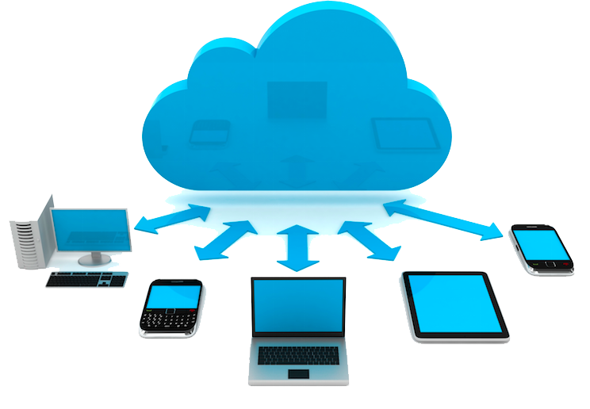

[This Photo](https://freepngimg.com/png/23747-cloud-computing-picture) by Unknown Author is licensed under [CC BY-NC](https://creativecommons.org/licenses/by-nc/3.0/)

# == Definition ==

The United States National Institute of Standards and Technology's definition of cloud computing identifies "five essential characteristics":

On-demand self-service. A consumer can unilaterally provision computing capabilities, such as server time and network storage, as needed automatically without requiring human interaction with each service provider.

Broad network access. Capabilities are available over the network and accessed through standard mechanisms that promote use by heterogeneous thin or thick client platforms (e.g., mobile phones, tablets, laptops, and workstations).

Resource pooling. The provider's computing resources are pooled to serve multiple consumers using a multi-tenant model, with different physical and virtual resources dynamically assigned and reassigned according to consumer demand.

Rapid elasticity. Capabilities can be elastically provisioned and released, in some cases automatically, to scale rapidly outward and inward commensurate with demand. To the consumer, the capabilities available for provisioning often appear unlimited and can be appropriated in any quantity at any time.

Measured service. Cloud systems automatically control and optimize resource use by leveraging a metering capability at some level of abstraction appropriate to the type of service (e.g., storage, processing, bandwidth, and active user accounts). Resource usage can be monitored, controlled, and reported, providing transparency for both the provider and consumer of the utilized service.

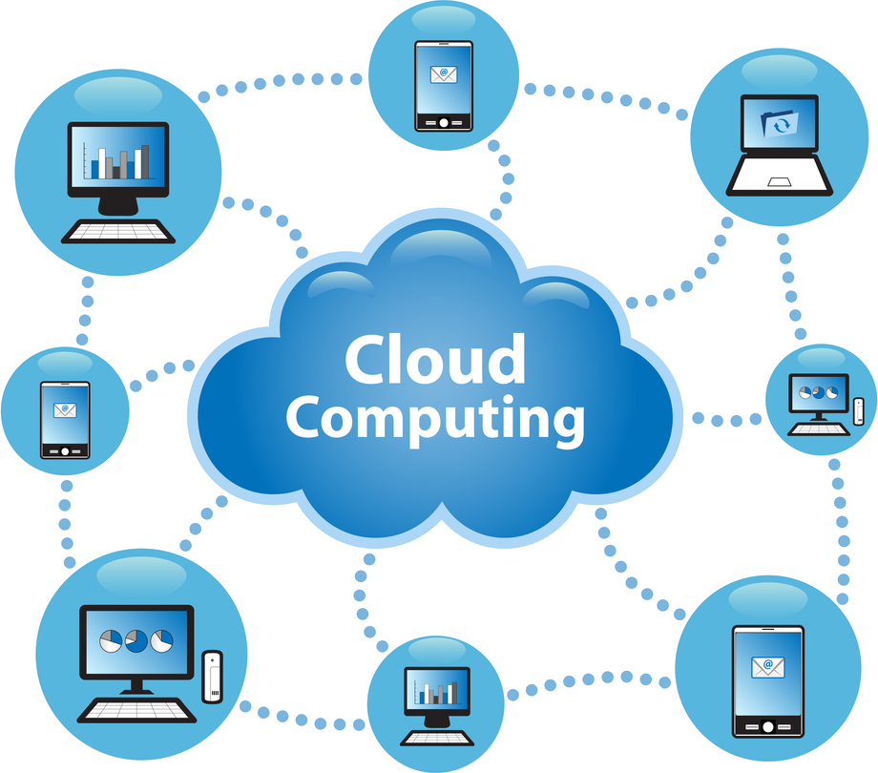

[This Photo](https://www.freepngimg.com/png/23920-cloud-computing-photos) by Unknown Author is licensed under [CC BY-NC](https://creativecommons.org/licenses/by-nc/3.0/)

# == History ==

Cloud computing has a rich history that extends back to the 1960s, with the initial concepts of time-sharing becoming popularized via remote job entry (RJE). The "data center" model, where users submitted jobs to operators to run on mainframes, was predominantly used during this era. This was a time of exploration and experimentation with ways to make large-scale computing power available to more users through time-sharing, optimizing the infrastructure, platform, and applications, and increasing efficiency for end users.The "cloud" metaphor for virtualized services dates to 1994, when it was used by General Magic for the universe of "places" that mobile agents in the Telescript environment could "go". The metaphor is credited to David Hoffman, a General Magic communications specialist, based on its long-standing use in networking and telecom. The expression cloud computing became more widely known in 1996 when Compaq Computer Corporation drew up a business plan for future computing and the Internet. The company's ambition was to supercharge sales with "cloud computing-enabled applications". The business plan foresaw that online consumer file storage would likely be commercially successful. As a result, Compaq decided to sell server hardware to internet service providers.In the 2000s, the application of cloud computing began to take shape with the establishment of Amazon Web Services (AWS) in 2002, which allowed developers to build applications independently. In 2006 the beta version of Google Docs was released, Amazon Simple Storage Service, known as Amazon S3, and the Amazon Elastic Compute Cloud (EC2), in 2008 NASA's development of the first open-source software for deploying private and hybrid clouds.The following decade saw the launch of various cloud services. In 2010, Microsoft launched Microsoft Azure, and Rackspace Hosting and NASA initiated an open-source cloud-software project, OpenStack. IBM introduced the IBM SmartCloud framework in 2011, and Oracle announced the Oracle Cloud in 2012. In December 2019, Amazon launched AWS Outposts, a service that extends AWS infrastructure, services, APIs, and tools to customer data centers, co-location spaces, or on-premises facilities.Since the global pandemic of 2020, cloud technology has surged in popularity due to the level of data security it offers and the flexibility of working options it provides for all employees, notably remote workers.

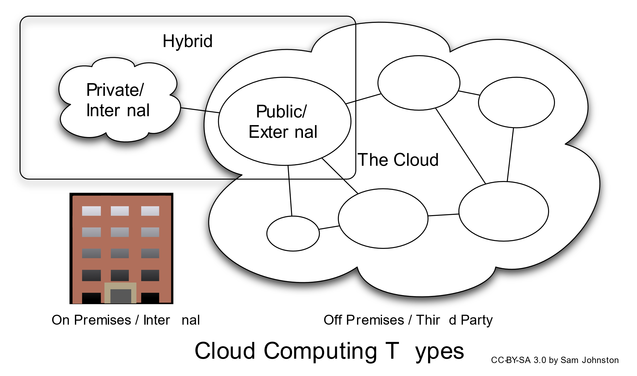

[This Photo](https://commons.wikimedia.org/wiki/File:Cloud_computing_types.svg) by Unknown Author is licensed under [CC BY-SA](https://creativecommons.org/licenses/by-sa/3.0/)

# == Value proposition ==

Advocates of public and hybrid clouds claim that cloud computing allows companies to avoid or minimize up-front IT infrastructure costs. Proponents also claim that cloud computing allows enterprises to get their applications up and running faster, with improved manageability and less maintenance, and that it enables IT teams to more rapidly adjust resources to meet fluctuating and unpredictable demand, providing burst computing capability: high computing power at certain periods of peak demand.Additional value propositions of cloud computing include:

# == Challenges and limitations ==

One of the main challenges of cloud computing, in comparison to more traditional on-premises computing, is data security and privacy. Cloud users entrust their sensitive data to third-party providers, who may not have adequate measures to protect it from unauthorized access, breaches, or leaks. Cloud users also face compliance risks if they have to adhere to certain regulations or standards regarding data protection, such as GDPR or HIPAA.Another challenge of cloud computing is reduced visibility and control. Cloud users may not have full insight into how their cloud resources are managed, configured, or optimized by their providers. They may also have limited ability to customize or modify their cloud services according to their specific needs or preferences. Complete understanding of all technology may be impossible, especially given the scale, complexity, and deliberate opacity of contemporary systems; however, there is a need for understanding complex technologies and their interconnections to have power and agency within them. The metaphor of the cloud can be seen as problematic as cloud computing retains the aura of something noumenal and numinous; it is something experienced without precisely understanding what it is or how it works.In addition, cloud migration is a significant issue. Cloud migration is the process of moving data, applications, or workloads from one cloud environment to another or from on-premises to the cloud. Cloud migration can be complex, time-consuming, and costly, especially if there are incompatibility issues between different cloud platforms or architectures. Cloud migration can also cause downtime, performance degradation, or data loss if not planned and executed properly.

# === Security and privacy ===

Cloud computing poses privacy concerns because the service provider can access the data that is in the cloud at any time. It could accidentally or deliberately alter or delete information. Many cloud providers can share information with third parties if necessary for purposes of law and order without a warrant. That is permitted in their privacy policies, which users must agree to before they start using cloud services. Solutions to privacy include policy and legislation as well as end-users' choices for how data is stored. Users can encrypt data that is processed or stored within the cloud to prevent unauthorized access. Identity management systems can also provide practical solutions to privacy concerns in cloud computing. These systems distinguish between authorized and unauthorized users and determine the amount of data that is accessible to each entity. The systems work by creating and describing identities, recording activities, and getting rid of unused identities.

According to the Cloud Security Alliance, the top three threats in the cloud are Insecure Interfaces and APIs, Data Loss & Leakage, and Hardware Failure—which accounted for 29%, 25% and 10% of all cloud security outages respectively. Together, these form shared technology vulnerabilities. In a cloud provider platform being shared by different users, there may be a possibility that information belonging to different customers resides on the same data server. Additionally, Eugene Schultz, chief technology officer at Emagined Security, said that hackers are spending substantial time and effort looking for ways to penetrate the cloud. "There are some real Achilles' heels in the cloud infrastructure that are making big holes for the bad guys to get into". Because data from hundreds or thousands of companies can be stored on large cloud servers, hackers can theoretically gain control of huge stores of information through a single attack—a process he called "hyperjacking". Some examples of this include the Dropbox security breach, and iCloud 2014 leak. Dropbox had been breached in October 2014, having over seven million of its users passwords stolen by hackers in an effort to get monetary value from it by Bitcoins (BTC). By having these passwords, they are able to read private data as well as have this data be indexed by search engines (making the information public).There is the problem of legal ownership of the data (If a user stores some data in the cloud, can the cloud provider profit from it?). Many Terms of Service agreements are silent on the question of ownership. Physical control of the computer equipment (private cloud) is more secure than having the equipment off-site and under someone else's control (public cloud). This delivers great incentive to public cloud computing service providers to prioritize building and maintaining strong management of secure services. Some small businesses that do not have expertise in IT security could find that it is more secure for them to use a public cloud. There is the risk that end users do not understand the issues involved when signing on to a cloud service (persons sometimes do not read the many pages of the terms of service agreement, and just click "Accept" without reading). This is important now that cloud computing is common and required for some services to work, for example for an intelligent personal assistant (Apple's Siri or Google Assistant). Fundamentally, private cloud is seen as more secure with higher levels of control for the owner, however public cloud is seen to be more flexible and requires less time and money investment from the user.The attacks that can be made on cloud computing systems include man-in-the middle attacks, phishing attacks, authentication attacks, and malware attacks. One of the largest threats is considered to be malware attacks, such as Trojan horses. Recent research conducted in 2022 has revealed that the Trojan horse injection method is a serious problem with harmful impacts on cloud computing systems.

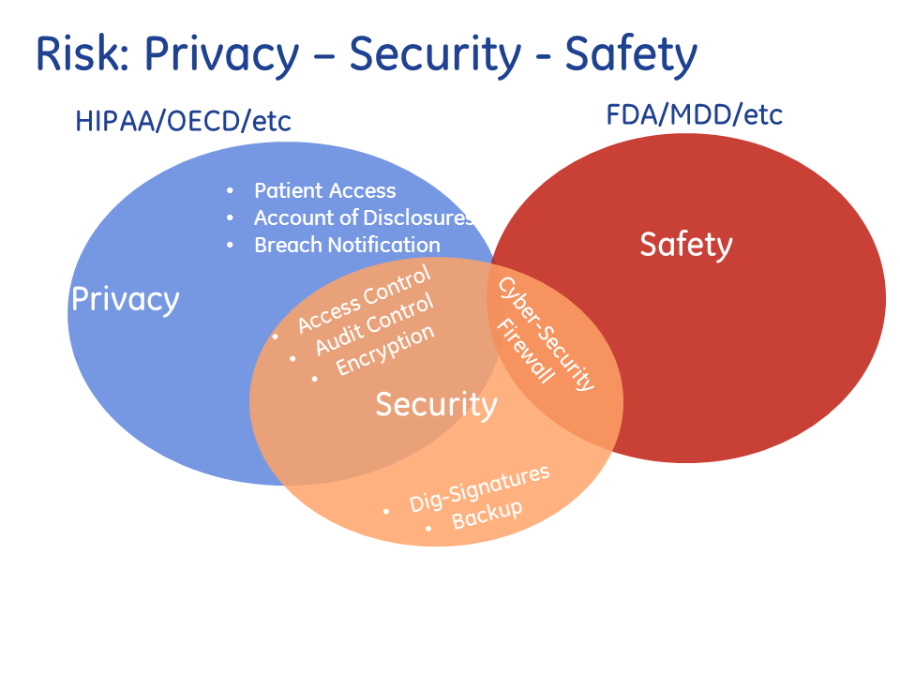

[This Photo](https://healthcaresecprivacy.blogspot.com/2017/01/) by Unknown Author is licensed under [CC BY-SA-NC](https://creativecommons.org/licenses/by-nc-sa/3.0/)

# == Service models ==

The service-oriented architecture (SOA) promotes the idea of "Everything as a Service" (EaaS or XaaS, or simply aAsS). This concept is operationalized in cloud computing through several service models as defined by the National Institute of Standards and Technology (NIST). The three standard service models are Infrastructure as a Service (IaaS), Platform as a Service (PaaS), and Software as a Service (SaaS). They are commonly depicted as layers in a stack, providing different levels of abstraction. However, these layers are not necessarily interdependent. For instance, SaaS can be delivered on bare metal, bypassing PaaS and IaaS, and a program can run directly on IaaS without being packaged as SaaS.

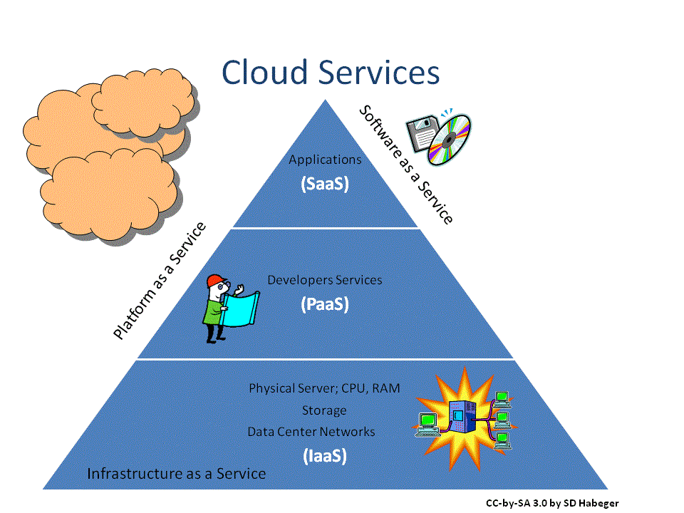

[This Photo](https://www.techstagram.com/2013/02/19/types-of-cloud/) by Unknown Author is licensed under [CC BY-NC-ND](https://creativecommons.org/licenses/by-nc-nd/3.0/)

# === Infrastructure as a service (IaaS) ===

"Infrastructure as a service" (IaaS) refers to online services that provide high-level APIs used to abstract various low-level details of underlying network infrastructure like physical computing resources, location, data partitioning, scaling, security, backup, etc. A hypervisor runs the virtual machines as guests. Pools of hypervisors within the cloud operational system can support large numbers of virtual machines and the ability to scale services up and down according to customers' varying requirements. Linux containers run in isolated partitions of a single Linux kernel running directly on the physical hardware. Linux cgroups and namespaces are the underlying Linux kernel technologies used to isolate, secure and manage the containers. The use of containers offers higher performance than virtualization because there is no hypervisor overhead. IaaS clouds often offer additional resources such as a virtual-machine disk-image library, raw block storage, file or object storage, firewalls, load balancers, IP addresses, virtual local area networks (VLANs), and software bundles.The NIST's definition of cloud computing describes IaaS as "where the consumer is able to deploy and run arbitrary software, which can include operating systems and applications. The consumer does not manage or control the underlying cloud infrastructure but has control over operating systems, storage, and deployed applications; and possibly limited control of select networking components (e.g., host firewalls)."IaaS-cloud providers supply these resources on-demand from their large pools of equipment installed in data centers. For wide-area connectivity, customers can use either the Internet or carrier clouds (dedicated virtual private networks). To deploy their applications, cloud users install operating-system images and their application software on the cloud infrastructure. In this model, the cloud user patches and maintains the operating systems and the application software. Cloud providers typically bill IaaS services on a utility computing basis: cost reflects the number of resources allocated and consumed.

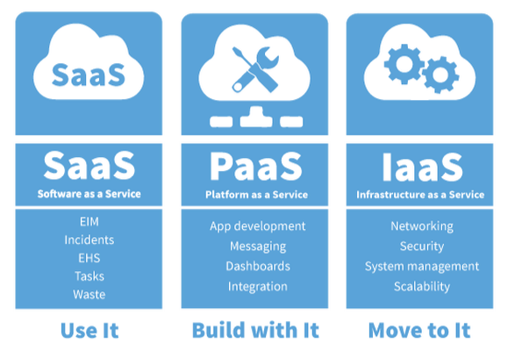

[This Photo](https://blog.zhiweiyin.com/post/%E6%B7%B1%E5%85%A5%E5%89%96%E6%9E%90kubernetes-%E5%AD%A6%E4%B9%A0%E7%AC%94%E8%AE%B0-history/) by Unknown Author is licensed under [CC BY-NC-ND](https://creativecommons.org/licenses/by-nc-nd/3.0/)

# === Platform as a service (PaaS) ===

The NIST's definition of cloud computing defines Platform as a Service as:

The capability provided to the consumer is to deploy onto the cloud infrastructure consumer-created or acquired applications created using programming languages, libraries, services, and tools supported by the provider. The consumer does not manage or control the underlying cloud infrastructure including network, servers, operating systems, or storage, but has control over the deployed applications and possibly configuration settings for the application-hosting environment.

PaaS vendors offer a development environment to application developers. The provider typically develops toolkit and standards for development and channels for distribution and payment. In the PaaS models, cloud providers deliver a computing platform, typically including an operating system, programming-language execution environment, database, and the web server. Application developers develop and run their software on a cloud platform instead of directly buying and managing the underlying hardware and software layers. With some PaaS, the underlying computer and storage resources scale automatically to match application demand so that the cloud user does not have to allocate resources manually.Some integration and data management providers also use specialized applications of PaaS as delivery models for data. Examples include iPaaS (Integration Platform as a Service) and dPaaS (Data Platform as a Service). iPaaS enables customers to develop, execute and govern integration flows. Under the iPaaS integration model, customers drive the development and deployment of integrations without installing or managing any hardware or middleware. dPaaS delivers integration—and data-management—products as a fully managed service. Under the dPaaS model, the PaaS provider, not the customer, manages the development and execution of programs by building data applications for the customer. dPaaS users access data through data-visualization tools.

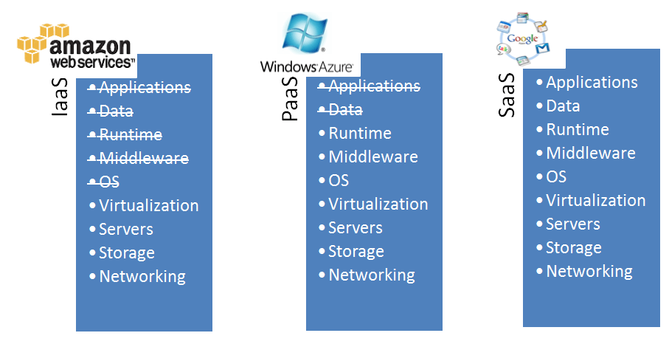

[This Photo](http://insightextractor.com/tag/platform-as-a-service/) by Unknown Author is licensed under [CC BY-SA-NC](https://creativecommons.org/licenses/by-nc-sa/3.0/)

# === Software as a service (SaaS) ===

The NIST's definition of cloud computing defines Software as a Service as:

The capability provided to the consumer is to use the provider's applications running on a cloud infrastructure. The applications are accessible from various client devices through either a thin client interface, such as a web browser (e.g., web-based email), or a program interface. The consumer does not manage or control the underlying cloud infrastructure including network, servers, operating systems, storage, or even individual application capabilities, with the possible exception of limited user-specific application configuration settings.

In the software as a service (SaaS) model, users gain access to application software and databases. Cloud providers manage the infrastructure and platforms that run the applications. SaaS is sometimes referred to as "on-demand software" and is usually priced on a pay-per-use basis or using a subscription fee. In the SaaS model, cloud providers install and operate application software in the cloud and cloud users access the software from cloud clients. Cloud users do not manage the cloud infrastructure and platform where the application runs. This eliminates the need to install and run the application on the cloud user's own computers, which simplifies maintenance and support. Cloud applications differ from other applications in their scalability—which can be achieved by cloning tasks onto multiple virtual machines at run-time to meet changing work demand. Load balancers distribute the work over the set of virtual machines. This process is transparent to the cloud user, who sees only a single access-point. To accommodate a large number of cloud users, cloud applications can be multitenant, meaning that any machine may serve more than one cloud-user organization.

The pricing model for SaaS applications is typically a monthly or yearly flat fee per user, so prices become scalable and adjustable if users are added or removed at any point. It may also be free. Proponents claim that SaaS gives a business the potential to reduce IT operational costs by outsourcing hardware and software maintenance and support to the cloud provider. This enables the business to reallocate IT operations costs away from hardware/software spending and from personnel expenses, towards meeting other goals. In addition, with applications hosted centrally, updates can be released without the need for users to install new software. One drawback of SaaS comes with storing the users' data on the cloud provider's server. As a result, there could be unauthorized access to the data. Examples of applications offered as SaaS are games and productivity software like Google Docs and Office Online. SaaS applications may be integrated with cloud storage or File hosting services, which is the case with Google Docs being integrated with Google Drive, and Office Online being integrated with OneDrive.

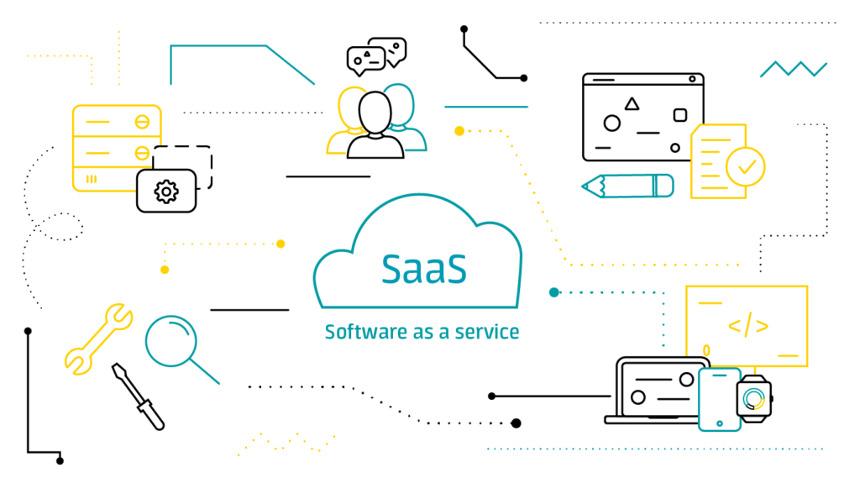

[This Photo](https://technofaq.org/posts/2020/06/what-is-saas-software-as-a-service-your-faqs-answered/) by Unknown Author is licensed under [CC BY-SA-NC](https://creativecommons.org/licenses/by-nc-sa/3.0/)

# === Mobile "backend" as a service (MBaaS) ===

In the mobile "backend" as a service (m) model, also known as "backend as a service" (BaaS), web app and mobile app developers are provided with a way to link their applications to cloud storage and cloud computing services with application programming interfaces (APIs) exposed to their applications and custom software development kits (SDKs). Services include user management, push notifications, integration with social networking services and more. This is a relatively recent model in cloud computing, with most BaaS startups dating from 2011 or later but trends indicate that these services are gaining significant mainstream traction with enterprise consumers.

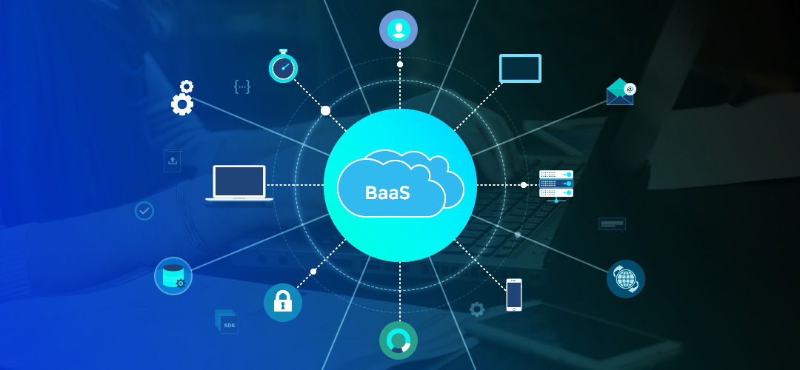

[This Photo](https://trungquandev.com/xin-chao-serverless-chung-ta-lam-quen-voi-nhau-nhe/) by Unknown Author is licensed under [CC BY-NC-ND](https://creativecommons.org/licenses/by-nc-nd/3.0/)

# === Serverless computing or Function-as-a-Service (FaaS) ===

Serverless computing is a cloud computing code execution model in which the cloud provider fully manages starting and stopping virtual machines as necessary to serve requests. Requests are billed by an abstract measure of the resources required to satisfy the request, rather than per virtual machine per hour. Despite the name, serverless computing does not actually involve running code without servers. The business or person using the system does not have to purchase, rent or provide servers or virtual machines for the back-end code to run on.

Function as a service (FaaS) is a service-hosted remote procedure call that utilizes serverless computing to enable deploying individual functions in the cloud to run in response to events. Some consider FaaS to fall under the umbrella of serverless computing, while others use the terms interchangeably.

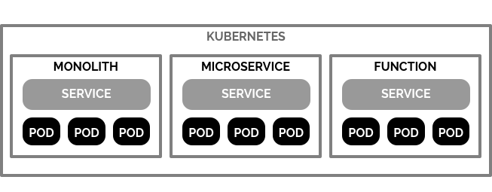

[This Photo](https://imti.co/fass-kubeless-kubernetes/) by Unknown Author is licensed under [CC BY](https://creativecommons.org/licenses/by/3.0/)

# === Private ===

Private cloud is cloud infrastructure operated solely for a single organization, whether managed internally or by a third party, and hosted either internally or externally. Undertaking a private cloud project requires significant engagement to virtualize the business environment, and requires the organization to reevaluate decisions about existing resources. It can improve business, but every step in the project raises security issues that must be addressed to prevent serious vulnerabilities. Self-run data centers are generally capital intensive. They have a significant physical footprint, requiring allocations of space, hardware, and environmental controls. These assets have to be refreshed periodically, resulting in additional capital expenditures. They have attracted criticism because users "still have to buy, build, and manage them" and thus do not benefit from less hands-on management, essentially "[lacking] the economic model that makes cloud computing such an intriguing concept".

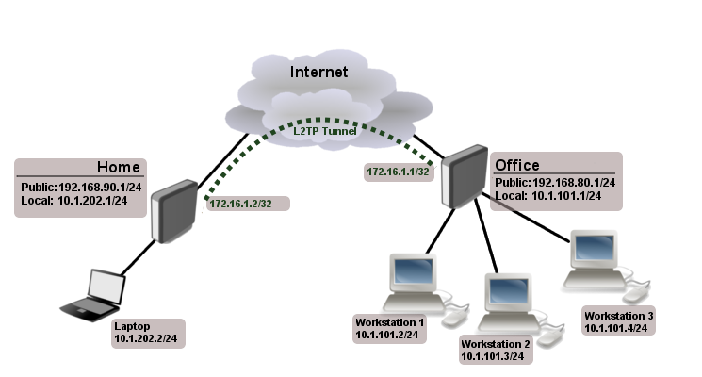

[This Photo](https://librewiki.net/wiki/%EA%B0%80%EC%83%81_%EC%82%AC%EC%84%A4%EB%A7%9D) by Unknown Author is licensed under [CC BY-SA](https://creativecommons.org/licenses/by-sa/3.0/)

# === Public ===

Cloud services are considered "public" when they are delivered over the public Internet, and they may be offered as a paid subscription, or free of charge. Architecturally, there are few differences between public- and private-cloud services, but security concerns increase substantially when services (applications, storage, and other resources) are shared by multiple customers. Most public-cloud providers offer direct-connection services that allow customers to securely link their legacy data centers to their cloud-resident applications.Several factors like the functionality of the solutions, cost, integrational and organizational aspects as well as safety & security are influencing the decision of enterprises and organizations to choose a public cloud or on-premises solution.

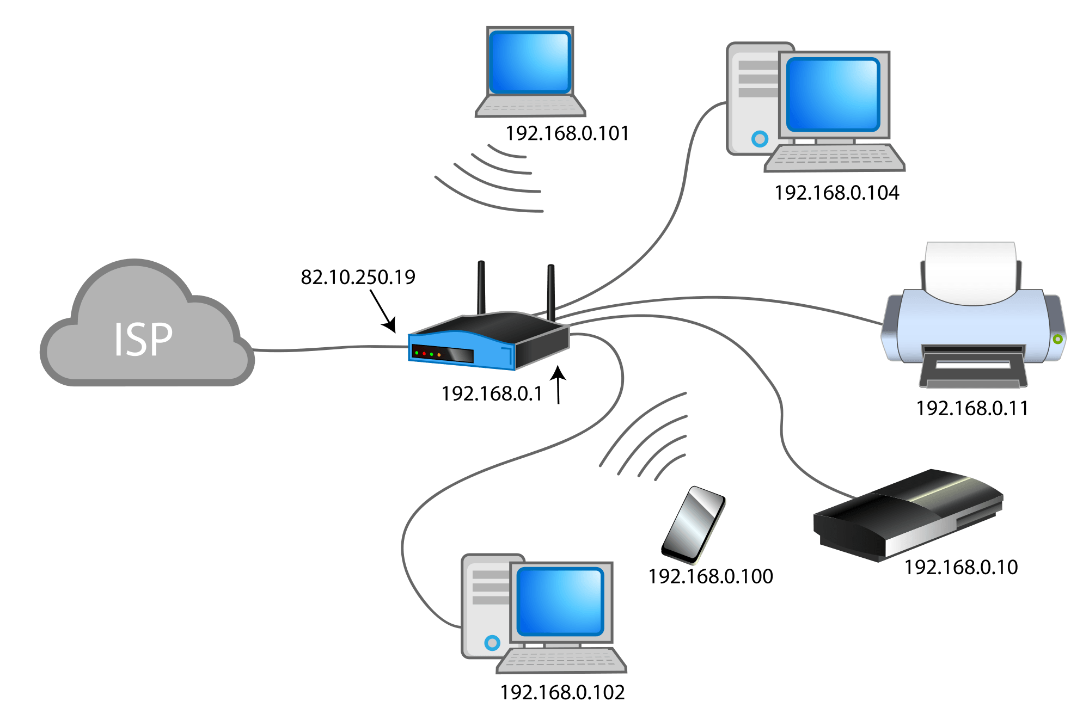

[This Photo](https://mascandobits.es/programacion/configurar-servidor-dns-cache-con-tu-raspberry-pi-para-mejorar-la-velocidad-del-trafico-de-tu-red-local/) by Unknown Author is licensed under [CC BY-NC](https://creativecommons.org/licenses/by-nc/3.0/)

# === Hybrid ===

Hybrid cloud is a composition of a public cloud and a private environment, such as a private cloud or on-premises resources, that remain distinct entities but are bound together, offering the benefits of multiple deployment models. Hybrid cloud can also mean the ability to connect collocation, managed and/or dedicated services with cloud resources. Gartner defines a hybrid cloud service as a cloud computing service that is composed of some combination of private, public and community cloud services, from different service providers. A hybrid cloud service crosses isolation and provider boundaries so that it cannot be simply put in one category of private, public, or community cloud service. It allows one to extend either the capacity or the capability of a cloud service, by aggregation, integration or customization with another cloud service.

Varied use cases for hybrid cloud composition exist. For example, an organization may store sensitive client data in house on a private cloud application, but interconnect that application to a business intelligence application provided on a public cloud as a software service. This example of hybrid cloud extends the capabilities of the enterprise to deliver a specific business service through the addition of externally available public cloud services. Hybrid cloud adoption depends on a number of factors such as data security and compliance requirements, level of control needed over data, and the applications an organization uses.Another example of hybrid cloud is one where IT organizations use public cloud computing resources to meet temporary capacity needs that can not be met by the private cloud. This capability enables hybrid clouds to employ cloud bursting for scaling across clouds. Cloud bursting is an application deployment model in which an application runs in a private cloud or data center and "bursts" to a public cloud when the demand for computing capacity increases. A primary advantage of cloud bursting and a hybrid cloud model is that an organization pays for extra compute resources only when they are needed. Cloud bursting enables data centers to create an in-house IT infrastructure that supports average workloads, and use cloud resources from public or private clouds, during spikes in processing demands.

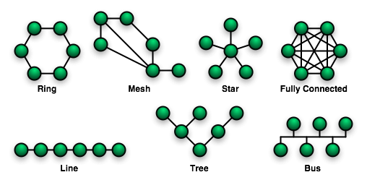

[This Photo](https://www.stefanux.de/wiki/doku.php/netzwerke/netzwerk-topologien) by Unknown Author is licensed under [CC BY-SA-NC](https://creativecommons.org/licenses/by-nc-sa/3.0/)

# ==== Community ====

Community cloud shares infrastructure between several organizations from a specific community with common concerns (security, compliance, jurisdiction, etc.), whether managed internally or by a third-party, and either hosted internally or externally. The costs are spread over fewer users than a public cloud (but more than a private cloud), so only some of the cost savings potential of cloud computing are realized.

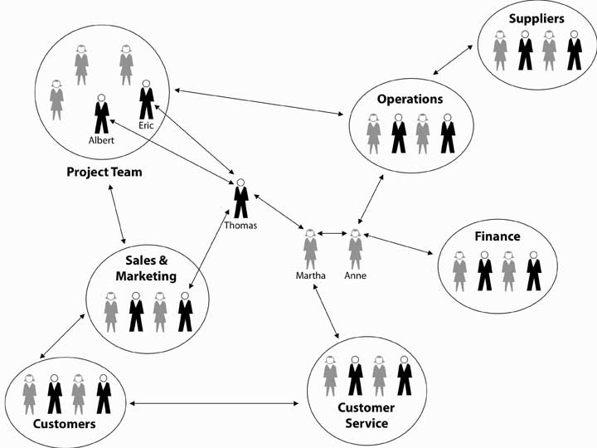

[This Photo](https://open.lib.umn.edu/principlesmanagement/chapter/9-3-an-introduction-to-the-lexicon-of-social-networks/) by Unknown Author is licensed under [CC BY-SA-NC](https://creativecommons.org/licenses/by-nc-sa/3.0/)

# ==== Distributed ====

A cloud computing platform can be assembled from a distributed set of machines in different locations, connected to a single network or hub service. It is possible to distinguish between two types of distributed clouds: public-resource computing and volunteer cloud.

Public-resource computing – This type of distributed cloud results from an expansive definition of cloud computing, because they are more akin to distributed computing than cloud computing. Nonetheless, it is considered a sub-class of cloud computing.

Volunteer cloud – Volunteer cloud computing is characterized as the intersection of public-resource computing and cloud computing, where a cloud computing infrastructure is built using volunteered resources. Many challenges arise from this type of infrastructure, because of the volatility of the resources used to build it and the dynamic environment it operates in. It can also be called peer-to-peer clouds, or ad-hoc clouds. An interesting effort in such direction is Cloud@Home, it aims to implement a cloud computing infrastructure using volunteered resources providing a business-model to incentivize contributions through financial restitution.

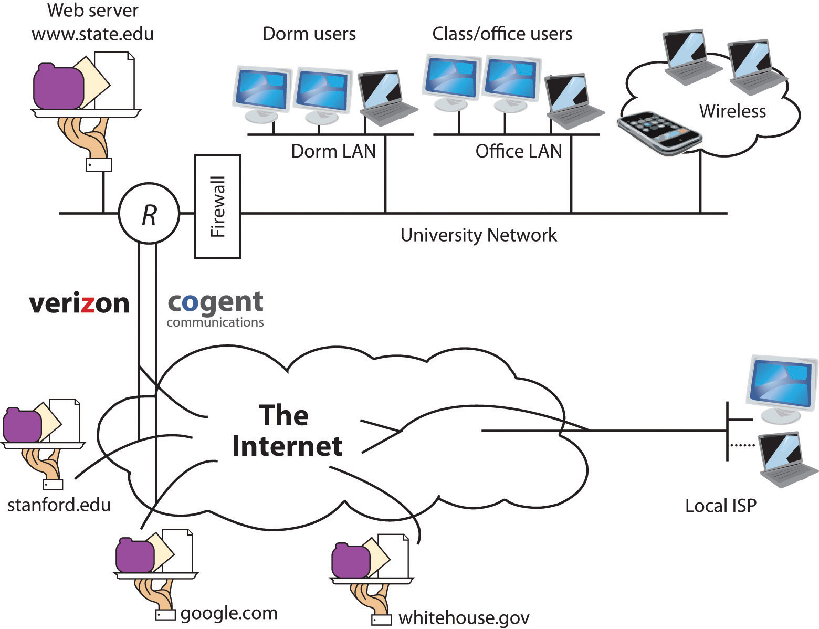

[This Photo](https://uhlibraries.pressbooks.pub/mis3300/chapter/the-internet/) by Unknown Author is licensed under [CC BY-SA-NC](https://creativecommons.org/licenses/by-nc-sa/3.0/)

# ==== Multi ====

Multicloud is the use of multiple cloud computing services in a single heterogeneous architecture to reduce reliance on single vendors, increase flexibility through choice, mitigate against disasters, etc. It differs from hybrid cloud in that it refers to multiple cloud services, rather than multiple deployment modes (public, private, legacy).

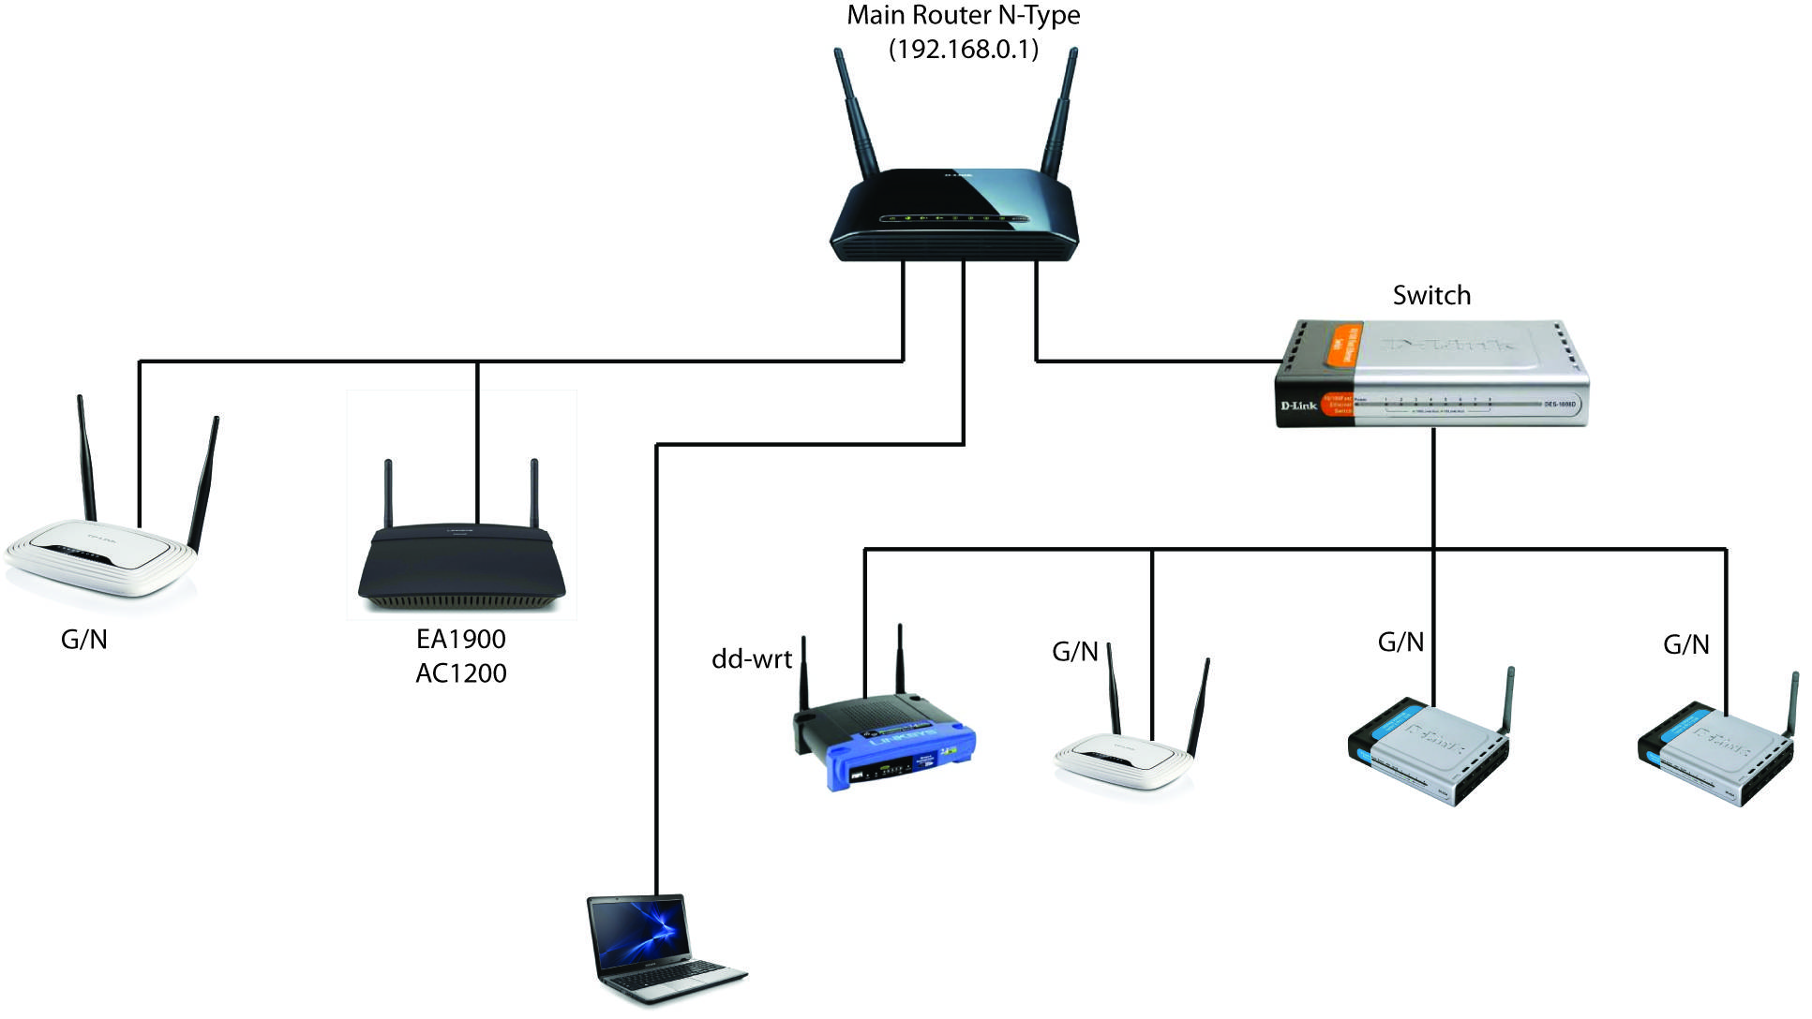

[This Photo](http://superuser.com/questions/994563/multiple-routers-access-point-setup/994584) by Unknown Author is licensed under [CC BY-SA](https://creativecommons.org/licenses/by-sa/3.0/)

# ==== Poly ====

Poly cloud refers to the use of multiple public clouds for the purpose of leveraging specific services that each provider offers. It differs from Multi cloud in that it is not designed to increase flexibility or mitigate against failures but is rather used to allow an organization to achieve more that could be done with a single provider.

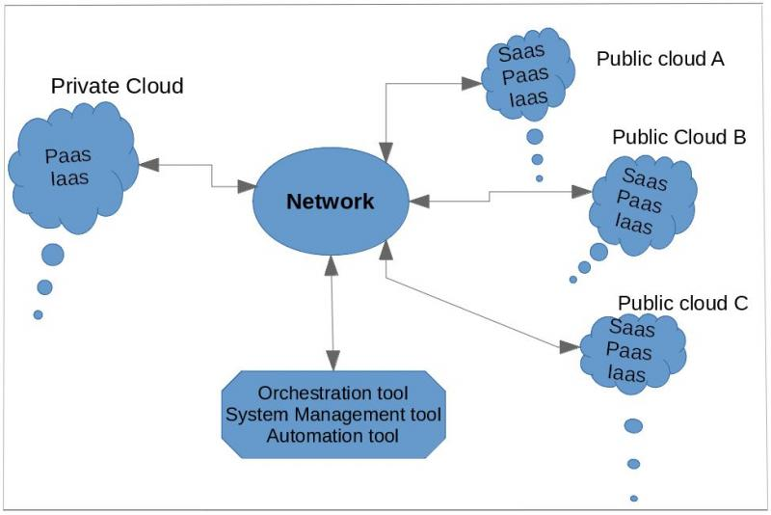

[This Photo](https://opensource.com/article/17/7/what-is-hybrid-cloud) by Unknown Author is licensed under [CC BY-SA](https://creativecommons.org/licenses/by-sa/3.0/)

# ==== Big data ====

The issues of transferring large amounts of data to the cloud as well as data security once the data is in the cloud initially hampered adoption of cloud for big data, but now that much data originates in the cloud and with the advent of bare-metal servers, the cloud has become a solution for use cases including business analytics and geospatial analysis.

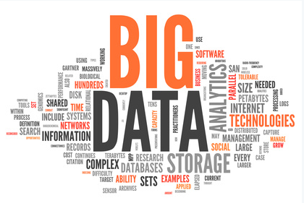

[This Photo](https://ask.hellobi.com/blog/dataman/2286) by Unknown Author is licensed under [CC BY-SA](https://creativecommons.org/licenses/by-sa/3.0/)

# ==== HPC ====

HPC cloud refers to the use of cloud computing services and infrastructure to execute high-performance computing (HPC) applications. These applications consume a considerable amount of computing power and memory and are traditionally executed on clusters of computers. In 2016 a handful of companies, including R-HPC, Amazon Web Services, Univa, Silicon Graphics International, Sabalcore, Gomput, and Penguin Computing offered a high-performance computing cloud. The Penguin On Demand (POD) cloud was one of the first non-virtualized remote HPC services offered on a pay-as-you-go basis. Penguin Computing launched its HPC cloud in 2016 as an alternative to Amazon's EC2 Elastic Compute Cloud, which uses virtualized computing nodes.

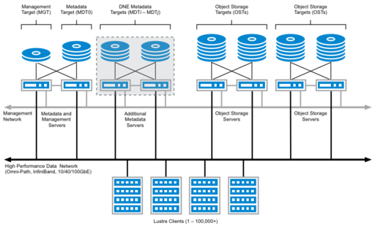

[This Photo](https://wiki.lustre.org/Lustre_Server_Requirements_Guidelines) by Unknown Author is licensed under [CC BY-SA](https://creativecommons.org/licenses/by-sa/3.0/)

# == Architecture ==

Cloud architecture, the systems architecture of the software systems involved in the delivery of cloud computing, typically involves multiple cloud components communicating with each other over a loose coupling mechanism such as a messaging queue. Elastic provision implies intelligence in the use of tight or loose coupling as applied to mechanisms such as these and others.



[This Photo](https://www.techstagram.com/2013/02/19/types-of-cloud/) by Unknown Author is licensed under [CC BY-NC-ND](https://creativecommons.org/licenses/by-nc-nd/3.0/)

# === Cloud engineering ===

Cloud engineering is the application of engineering disciplines of cloud computing. It brings a systematic approach to the high-level concerns of commercialization, standardization and governance in conceiving, developing, operating and maintaining cloud computing systems. It is a multidisciplinary method encompassing contributions from diverse areas such as systems, software, web, performance, information technology engineering, security, platform, risk, and quality engineering.

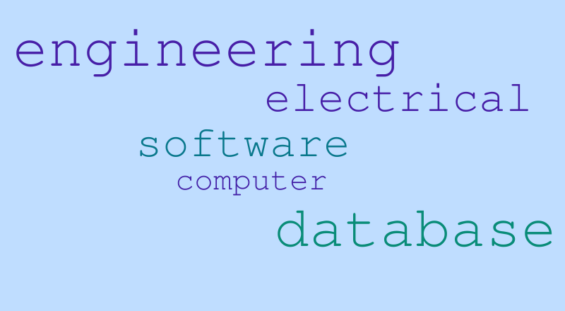

[This Photo](https://worditout.com/word-cloud/120429) by Unknown Author is licensed under [CC BY-NC-ND](https://creativecommons.org/licenses/by-nc-nd/3.0/)

# == Market ==

According to International Data Corporation (IDC), global spending on cloud computing services has reached $706 billion and expected to reach $1.3 trillion by 2025. While Gartner estimated that global public cloud services end-user spending would reach $600 billion by 2023. As per a McKinsey & Company report, cloud cost-optimization levers and value-oriented business use cases foresee more than $1 trillion in run-rate EBITDA across Fortune 500 companies as up for grabs in 2030. In 2022, more than $1.3 trillion in enterprise IT spending was at stake from the shift to the cloud, growing to almost $1.8 trillion in 2025, according to Gartner.

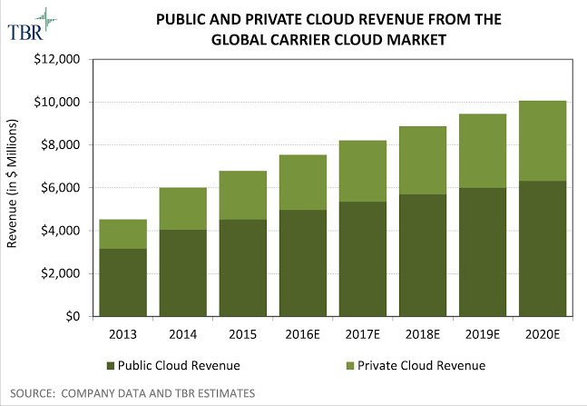

[This Photo](https://blog.geoactivegroup.com/2016/07/upside-for-cloud-computing-value-added.html) by Unknown Author is licensed under [CC BY-SA](https://creativecommons.org/licenses/by-sa/3.0/)

# == List of clouds ==

Adobe Creative Cloud

Amazon Web Services

Google Cloud

IBM Cloud

Microsoft Azure

OpenStack

Oracle Cloud

Panorama9

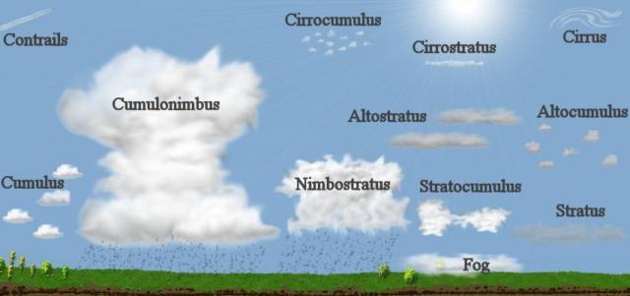

[This Photo](https://greencomet.org/tag/clouds/) by Unknown Author is licensed under [CC BY-SA](https://creativecommons.org/licenses/by-sa/3.0/)

# == Similar concepts ==

The goal of cloud computing is to allow users to take benefit from all of these technologies, without the need for deep knowledge about or expertise with each one of them. The cloud aims to cut costs and helps the users focus on their core business instead of being impeded by IT obstacles. The main enabling technology for cloud computing is virtualization. Virtualization software separates a physical computing device into one or more "virtual" devices, each of which can be easily used and managed to perform computing tasks. With operating system–level virtualization essentially creating a scalable system of multiple independent computing devices, idle computing resources can be allocated and used more efficiently. Virtualization provides the agility required to speed up IT operations and reduces cost by increasing infrastructure utilization. Autonomic computing automates the process through which the user can provision resources on-demand. By minimizing user involvement, automation speeds up the process, reduces labor costs and reduces the possibility of human errors.Cloud computing uses concepts from utility computing to provide metrics for the services used. Cloud computing attempts to address QoS (quality of service) and reliability problems of other grid computing models.Cloud computing shares characteristics with:

Client–server model – Client–server computing refers broadly to any distributed application that distinguishes between service providers (servers) and service requestors (clients).

Computer bureau – A service bureau providing computer services, particularly from the 1960s to 1980s.

Grid computing – A form of distributed and parallel computing, whereby a 'super and virtual computer' is composed of a cluster of networked, loosely coupled computers acting in concert to perform very large tasks.

Fog computing – Distributed computing paradigm that provides data, compute, storage and application services closer to the client or near-user edge devices, such as network routers. Furthermore, fog computing handles data at the network level, on smart devices and on the end-user client-side (e.g. mobile devices), instead of sending data to a remote location for processing.

Utility computing – The "packaging of computing resources, such as computation and storage, as a metered service similar to a traditional public utility, such as electricity."

Peer-to-peer – A distributed architecture without the need for central coordination. Participants are both suppliers and consumers of resources (in contrast to the traditional client-server model).

Cloud sandbox – A live, isolated computer environment in which a program, code or file can run without affecting the application in which it runs.

# == References ==

Millard, Christopher (2013). Cloud Computing Law. Oxford University Press. ISBN 978-0-19-967168-7.

Weisser, Alexander (2020). International Taxation of Cloud Computing. Editions Juridiques Libres, ISBN 978-2-88954-030-3.

Singh, Jatinder; Powles, Julia; Pasquier, Thomas; Bacon, Jean (July 2015). "Data Flow Management and Compliance in Cloud Computing". IEEE Cloud Computing. 2 (4): 24–32. doi:10.1109/MCC.2015.69. S2CID 9812531.

Armbrust, Michael; Stoica, Ion; Zaharia, Matei; Fox, Armando; Griffith, Rean; Joseph, Anthony D.; Katz, Randy; Konwinski, Andy; Lee, Gunho; Patterson, David; Rabkin, Ariel (1 April 2010). "A view of cloud computing". Communications of the ACM. 53 (4): 50. doi:10.1145/1721654.1721672. S2CID 1673644.

Hu, Tung-Hui (2015). A Prehistory of the Cloud. MIT Press. ISBN 978-0-262-02951-3.

Mell, P. (2011, September). The NIST Definition of Cloud Computing. Retrieved November 1, 2015, from National Institute of Standards and Technology website Media related to Cloud computing at Wikimedia Commons